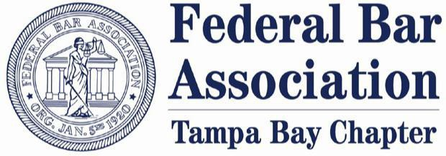

The Tampa Bay Chapter of the Federal Bar Association presents:
STAYING IN THE GAME: HOW TO BUILD YOUR BOARD OF DIRECTORS!

Title Sponsorship – SECURED
Includes featured recognition as the Title Sponsor of the Staying in the Game event on the invitations, promotional materials and announcements, and on the TBCFBA newsletter; listing as the Title Sponsor on the cover of the program for the in-person event; dedicated Title Sponsor appreciation on social media leading up to the event; sponsor name or logo to be featured at the event; verbal acknowledgement of the sponsor at the event; ability to bring appropriate firm-related promotional items (e.g. pens, notebooks, thumb drives) to be placed on each table at the in-person event; and admission for eight participants at the in-person event. Reserved table(s) at the event in front of stage.

Platinum Sponsorship – $3,000 (3 available)
Includes named recognition as a Platinum Sponsor on the invitations, promotional materials and announcements, and on the TBCFBA newsletter; listing as a Platinum Sponsor in the program for the in- person event; dedicated Platinum Sponsor appreciation on social media leading up to the event; sponsor name or logo to be featured at the event; ability to bring appropriate firm-related promotional items (e.g. pens, notebooks, thumb drives) to be placed on each table at the in-person event; and admission for six participants at the in-person event. Reserved table at the event.

Gold Sponsorship – $2,000
Includes named recognition as a Gold Sponsor on the invitations, promotional materials, and announcements; Gold Sponsor appreciation on social media leading up to the event; listing as a Gold Sponsor in the program for the in-person event; sponsor name or logo to be featured at the event; and admission for four participants at the in-person event.

Silver Sponsorship – $1,500
Includes named recognition as a Silver Sponsor on the invitations, promotional materials, and announcements; Silver Sponsor appreciation on social media leading up to the event; listing as a Silver Sponsor in the program for the in-person event; sponsor name or logo to be featured at the event; and admission for three participants at the in-person event.

Bronze Sponsorship – $1,000
Includes named recognition as a Bronze Sponsor on the invitations, promotional materials, and announcements; Bronze Sponsor appreciation on social media leading up to the event; listing as a Bronze Sponsor in the program for the in-person event; sponsor name or logo to be featured at the event; and admission for two participants at the in-person event.

Individual or Small Firm Sponsorship – $500
Includes named recognition as a Sponsor on the invitations, promotional materials, and announcements; Sponsor appreciation on social media leading up to the event; listing as a Sponsor in the program for the in-person event; sponsor name or logo to be featured at the event; and admission for one participant at the in-person event.

The Tampa Bay Chapter of the Federal Bar Association thanks you for your support!

Firm or Organization Name:

Contact Person:

Address:

Telephone Number:

Email Address:

Sponsorship Level:

Sponsorship Amount:

Checks should be made payable to the Tampa Bay Chapter of the Federal Bar Association. Please return to:

Porter Wright Morris & Arthur LLP
c/o Melissa Murphy
201 N. Franklin Street, Suite 1600
Tampa, FL 33602

